
- Subject Name and Code: ICT728 Capstone Project 1
- Tutor Name: Dr. Saeid Iranmanesh
- Assessment Title: Group Project Proposal

Family Name | Given Name | Student ID | Contribution % | Signature
Swarnaly | Marjana Akter | 20034447 | 25% | Marjana
Bhowmick | Tanmoy | 20034803 | 25% | Tanmoy
Thapa | Rejina | 20033751 | 25% | Rejina
Thapa | Binaya | 20033247 | 25% | Binaya

Table of Contents
1. Introduction & Background 2
1.1 The Problem Background 2
1.2 Industry Relevance 2
1.3 Stakeholders and Beneficiaries 3
1.3.1 External information-seekers: 4
1.3.2 Internal Stakeholders: 4
1.3.3 Delivery stakeholders: 5
1.4 Problem Statement 5
1.5 Project Aims and Objectives 5
1.6 Boundaries and Assumptions 5
2 Literature Review / Existing Solutions 6
2.3 Introduction 6
2.4 AI Chatbots in Organisations 6
2.5 Large Language Models (LLMs) 7
2.6 Hallucinations and Reliability 7
2.7 Retrieval-Augmented Generation (RAG) 7
2.8 Existing Enterprise Chatbot Platforms 8
2.9 Research Gap and Conclusions 8
3 Planning and Management 8
3.3 Project plan 8
3.4 Project Timeline 9
3.5 Milestone table 9
3.6 Roles and Responsibilities 11
3.7 Technical and Resources Feasibility 11
3.8 Risk Identification and Mitigation strategies 12
3.9 Ethical, legal, safety and sustainability consideration 12
4 Conclusion 13
- References 13

1. Introduction & Background

The Problem Background
The Institute of Information Management (IIM) is an organization that certifies and supports data-management professionals, and it runs on a mission-first basis rather than on making a profit for owners. Its main credentials are the Certified Data Protection Officer (CDPO) and the Certified Information Manager (CIM®), and it also offers training programs, professional events, membership, and advisory services. IIM’s major competitors are larger and more digitally advanced certification organizations such as ISACA, IAPP, PECB, and (ISC)².
However, this organization handles inquiries in an old way. For instance, questions about certifications, membership, fees, training, and events come in by email, phone, and web forms, and a small team answers each one by hand during business hours. Additionally, another major issue is that IIM's information is scattered across its web pages and held in its staff's knowledge, with no self-service option for people to find answers themselves. Consequently, the volume of inquiries is growing in direct proportion to the organizational growth, while the manual process of answering the questions has lost its scalability.

Industry Relevance
Mainly, two of the major recent trends make this problem rather than just inconvenient. The first one is the increasing demand for certified data protection professionals as privacy laws spread around the world. Whereas it is also included ongoing reform of Australia’s Privacy Act that increases the global time-zone-spread audience that certification bodies need to accommodate.
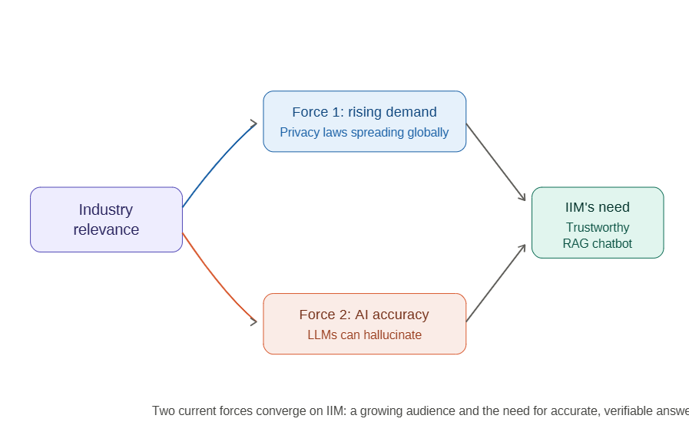
Figure 1: Two current forces converge on IIM.
Secondly, conversation-based AI has become the most common way to meet the demand for around-the-clock service, yet generative large language models tend to "hallucinate," giving answers that sound convincing but are actually wrong (Zhang and Zhang, 2025).
In the field of critical service settings, chatbots must respond more accurately based on the verified knowledge (Hong et al., 2025).
This is where the IIM is challenged. Thus, the reputation of this organization is built on trustworthy governance; it cannot use any conversational AI that misinforms the user. Arguably, this project applies the latest trustworthy AI methods to the organization whose trustworthiness is non-negotiable.

Stakeholders and Beneficiaries
IIM's stakeholders fall into three groups, and the chatbot affects each one differently.
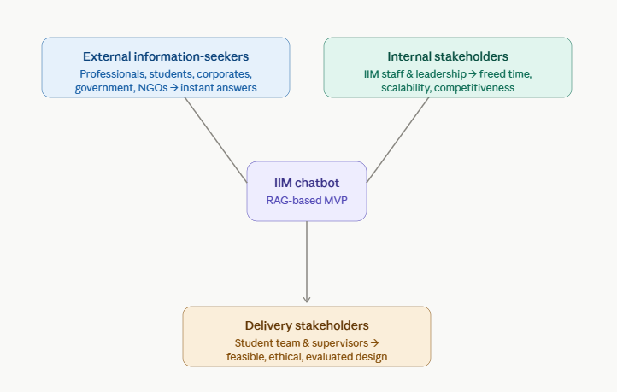
Figure 2: Stakeholders and Beneficiaries Diagram

External information-seekers:
These are specifically the practical users who come to IIM website for answers. For instance, they could be practicing professionals in data, IT, and compliance; students looking into certification options; corporate organizations in finance, telecommunications, healthcare, and education; government bodies and regulators; and international NGOs. At this point if they need some simple questions answered, they have to wait for business hours. While the chatbot gives the accurate answers instantly, which is the most crucial part for an offspring’s career decisions.

Internal Stakeholders:
All IIM’s staff members and leadership are in this group. Those are responsible for managing all the queries manually. However, the chatbot frees up their time for more valuable advisory work and, for the organization as a whole, improves engagement, scalability, and its ability to compete digitally.

Delivery stakeholders:
This group is essentially the student project team and academic supervisor, who are responsible for designing the solution properly, developing it ethically, and evaluating it honestly.

Problem Statement
Based on the current scenario, IIM does not have a scalable, 24/7 available, and reliable digital channel for stakeholder inquiries. Routine questions take up limited staff time, while people in different time zones wait for information that already exists within the organization. Since IIM is regulating worldwide, it is unacceptable for a governance-focused certification body to rely on rule-based chatbots, which cannot interpret naturally varied queries. Admittedly, the problem precisely is that IIM lacks a conversational interface that can understand natural language and gives answers grounded strictly in IIM’s own verified content.

Project Aims and Objectives
The purpose of this project is to design, develop, and evaluate a Retrieval-Augmented Generation (RAG) chatbot MVP. This approach already has been shown to greatly reduce hallucination while keeping answers accurate in customer-service circumstances (Rakin et al., 2025). This aim is broken down into three objectives:
- First of all, analyze IIM's stakeholder needs, types of inquiries, and information workflows to identify and prioritize the most useful chatbot use cases.
- Secondly, design a workable and trendy chatbot solution, including the conversation structure, knowledge base setup, fallback handling, and a justified choice of LLM and open-source tools.
- Finally, build a working MVP that answers questions about certifications, membership, training, and events using IIM's verified authentic content, test it with realistic user scenarios for accuracy and usability, and recommend how it could be deployed on IIM's website.

Boundaries and Assumptions
In scope: it consists of a demo-first MVP where the knowledge base is built from IIM's publicly available website content along with internal datasets provided by IIM. A functional web chat interface added to IIM's WordPress site and fallback responses that redirect unanswered questions to the staff.
Out of scope: marketing strategies, paid advertising, non-professional social media, payment processing, and personal or sensitive member data. The project assumes that IIM's non-sensitive, approved content is enough for prototyping, that free-tier AI services are good enough at MVP scale, and that the client will provide extra documents and feedback as the work progresses.

Literature Review / Existing Solutions

Introduction
The progress of the AI chatbots' development can be observed, from the basic systems based on rules to the more sophisticated and natural AI assistants using Large Language Models (LLMs) technologies. Those are widely used to improve the customer services, automate the process of answering the most frequent questions, and make conversations more relevant (Zhang et al., 2024; Wangsa et al., 2024). However, even with the rapid development, the current AI chatbots are still confronted with some significant issues such as hallucinations, inability to get access to the updated information of an organisation, accuracy and reliability problems (Zhao et al., 2023; Ji et al., 2023). This literature review explores the recent works concerning AI chatbots, LLMs, RAG and the available chatbot systems in order to define the current capabilities and research gap for the proposed AI chatbot solution for the Institute of Information Management (IIM).

AI Chatbots in Organisations
Chatbots based on artificial intelligence (AI) are becoming more relevant in assisting organizations in increasing their customers' engagement, performing automated enquiries and providing services more effectively. The latest achievements in natural language processing have facilitated chatbots to conduct more reliable and human-like communication in various fields, including education, health care and customer services (Zhang et al., 2024; Wangsa et al., 2024). Moreover, research proves that AI chatbots enhance the accessibility of services, shorten the time of replies and help users with the timely provision of information (Okonkwo and Ade-Ibijola, 2021; Labadze et al., 2023). Nevertheless, scientists state that there are some drawbacks in dealing with complex queries and organization-related information in chatbots' operations. They strongly rely on the availability of reliable information since the quality of the information can decrease user satisfaction (Wangsa et al., 2024; Labadze et al., 2023). This issue motivates scientists to develop more efficient AI systems, namely Large Language Models (LLMs).

Large Language Models (LLMs)
The introduction of Large Language Models (LLMs) has greatly enhanced the performance of AI chatbots through allowing natural, context-aware, and human-like conversations. The Large Language Models trained on massive amounts of data are capable of conducting various activities such as question-answering, text summarisation, and content creation in different fields (Zhao et al., 2023). However, due to their capacity of understanding contexts, they work better than conventional chatbots with rules. Nevertheless, several investigations have demonstrated that there are serious drawbacks associated with LLMs. For example, they can provide false or made-up answers, do not provide transparency, and are dependent on the quality of the training data (Muthusamy et al., 2023; Mialon et al., 2023).

Hallucinations and Reliability
Whereas LLMs provide fluent and contextually appropriate answers, at times they may also suffer from hallucinations where the answer generated by the model is not correct, not supported or not consistent with the information present. According to Ji et al. (2023), hallucination is one of the biggest problems facing natural language generation models. On the other hand, Huang et al. (2025) distinguish between factual and faithfulness hallucinations and analyze their cause during data, training, and inference processes. Such issues decrease the reliability of AI tools, especially when the domain requires information to be accurate and verifiable. Inaccurate information regarding certifications, memberships, and training provided by the organization like IIM may lower user’s trust.

Retrieval-Augmented Generation (RAG)
Retrieval-Augmented Generation (RAG) has become an effective method of enhancing the reliability and accuracy of LLM-based chatbots through the combination of language generation and retrieval of information from trusted external knowledge sources. The initial concept of RAG was introduced by Lewis et al. (2020), who have demonstrated the potential of document retrieval for the increase in factual accuracy and provision of more informed answers. Recent research findings also confirm that RAG minimises hallucinations, allows accessing current information related to organisational knowledge and improves the answer transparency due to evidence retrieved (Gao et al., 2023; Zhao et al., 2024). At the same time, scholars have pointed out the importance of knowledge base and retrieval quality since the retrieval of irrelevant or incomplete documents may affect answer accuracy (Asai et al., 2024). Hence, RAG provides a good basis for development of AI chatbots for enterprise that need to rely on reliable and specific information.

Existing Enterprise Chatbot Platforms
A number of chatbot development platforms are available to assist with the creation of enterprise conversational applications. The platform Botpress provides a managed and low-code platform with features for linking up organisational documentation and information, and is useful for quickly prototyping a system (Botpress, 2026). Rasa provides an open source platform with more flexibility in control over conversational structure, system integration and deployment (Rasa Technologies, 2026). While Botpress may be preferable for quick and easy development, Rasa may be better for flexibility and control over data. Ultimately, choice of platform will depend on the resources of IIM.

Research Gap and Conclusions
According to the literature review, AI chatbots, LLMs and RAGs have advanced significantly in improving conversational AI, however, there are still challenges that need to be addressed. Current literature addresses several gaps associated with response precision, retrieval performance, domain knowledge and enterprise adoption, as more research is required for practical use (Zhang et al., 2024; Gao et al., 2023).
As for the Institute of Information Management (IIM), there is a need to develop a chatbot providing information on certification, membership, training and consultation services, and ensuring privacy, governance and scalability. Consequently, the proposal is to use a RAG chatbot combined with the knowledge base of the organisation to ensure relevant responses.

3. Proposed Solution
The proposed solution is an AI chatbot to support responses to frequently asked questions (FAQs) by Institute of Information Management (IIM) Africa members. The bot will be able to provide accurate, up-to-date, and contextual information about membership, certification (CDPO, CIM), and payment options, among other details. It will be based on Retrieval-Augmented Generation (RAG) and use either Llama 3.2 (3B) via Ollama or OpenAI or another LLM API for the Large Language Model (LLM). The prototype will be developed using Llama 3.2 (3B) and Ollama, while the final model will be deployed as a lightweight widget on IIM Africa’s website.

4. System Overview
The system follows a client-server architecture. The front end comprises a responsive chatbot interface implemented in HTML, CSS, and JS that communicates with the backend through REST APIs. The Node.js/Express.js powered backend interacts with the RAG engine to fetch relevant content from the IIM knowledge bank that is used to construct appropriate responses alongside the user’s query to the LLM. In case of no relevant information being retrieved, the system either provides default guidance or directs the user to the IIM website. The response from the LLM is returned as JSON which is parsed and displayed as a chat message.

5. High-Level Architecture
Figure 1 is an overview of the system. The design decouples the presentation, application, intelligence, model serving, and knowledge storage layers to allow independent evolution while maximizing opportunities for reuse. This modularity implies that the model-serving implementation can be switched (between a local Llama deployment and/or the OpenAI API) with no impact on either the presentation or the retrieval logic.
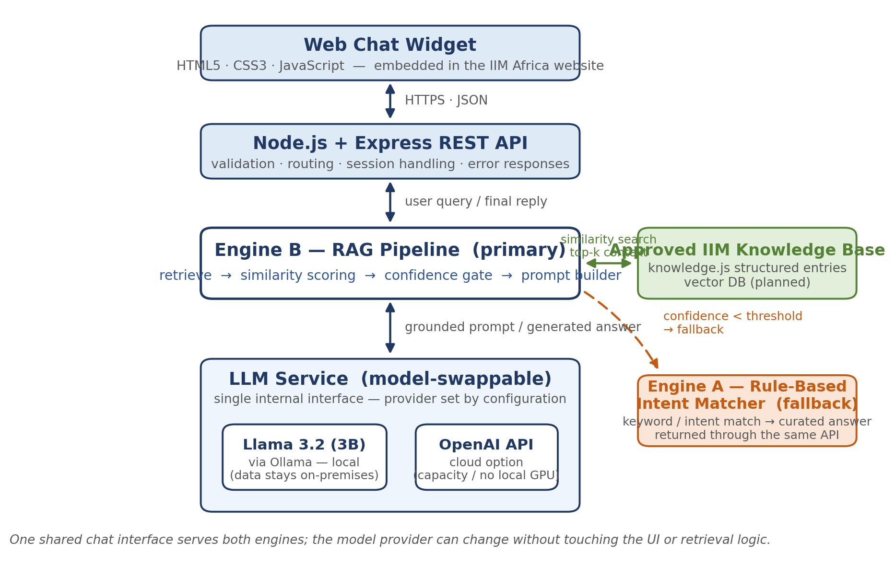
Figure 1: High-level system architecture of the IIM Africa FAQ chatbot.

The primary components are as follows:
- Frontend : The responsive chat widget implemented in HTML5/CSS3/JS for embedding in the IIM Africa website
- Backend : The Node.js/Express.js REST API with input validation and routing
- Engine B (primary): The RAG pipeline in rag.js that implements retrieval, similarity thresholding, confidence estimation, and prompt construction for the LLM
- Engine A (fallback): Rule-based intent classifier that provides pre-defined answers for common/frustrating queries
- LLM service: Switchable between Ollama (Llama3.2 3B) and OpenAI API for primary operations; fallback to basic rule-based responses when needed
- Knowledge base: Curated IIM content in knowledge.js, with future plans to transition to a vector database

6. LLM Workflow
Figure 2 summarize the request lifecycle for a single chat turn:
- The user asks a question in natural language in the chat widget
- the user asks a question in the chatbot interface
- the backend checks that the request is valid and sends it to the RAG engine
- the RAG engine finds relevant chunks of IIM knowledge by similarity
- those are fed to the LLM along with the query to generate an answer
- and the result is post-processed and sent back to the frontend as a chat message.
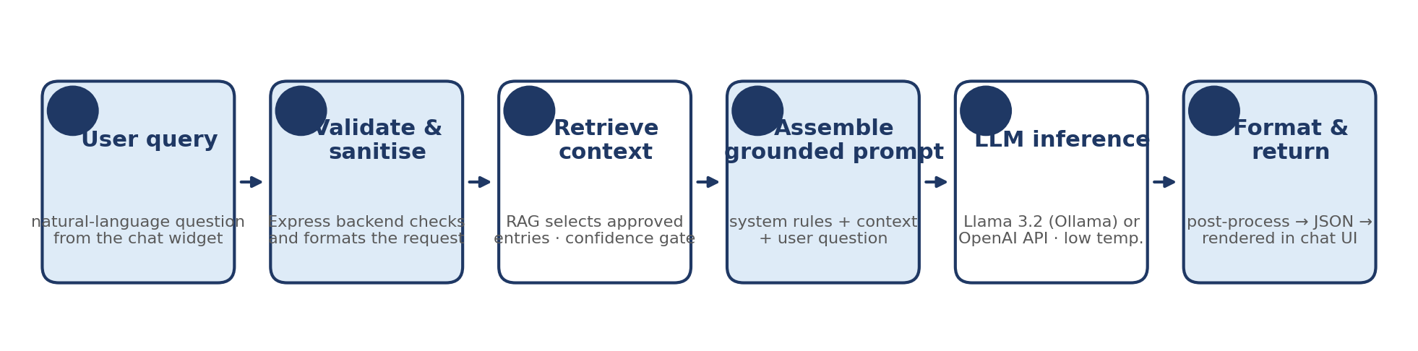
Figure 2: LLM request workflow for a single chat turn.

7. RAG Workflow
Retrieval-Augmented Generation employs a two-step process (see Figure 3). The Retrieval Augmented Generation system takes the approved IIM information and puts it in a structured knowledge base. Queries are matched against this information according to similarity scores, and only those passes a certain threshold are used to generate the response to the user. This method allows for more accurate, more focused answers, as well as reducing hallucinations and updating the knowledge base without needing to retrain the language model itself (Gao et al., 2023).
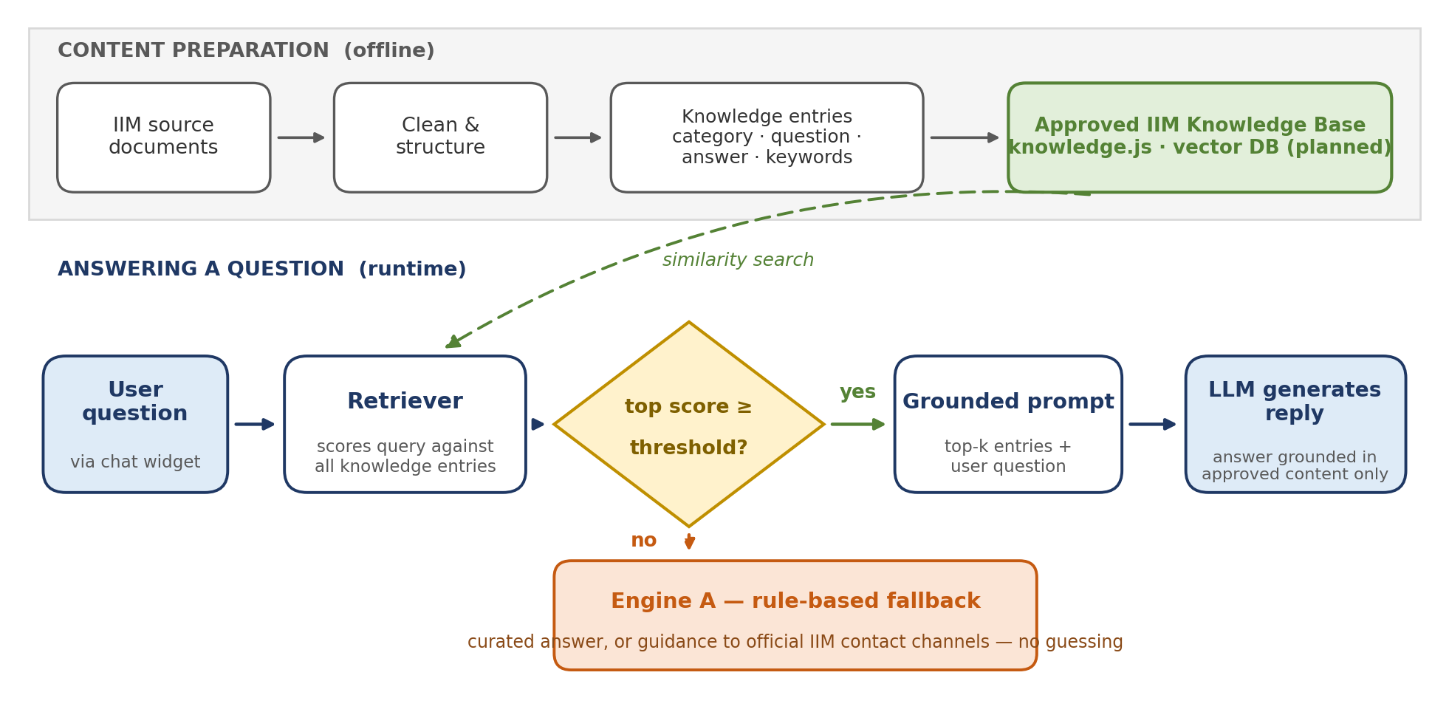
Figure 3: RAG pipeline — offline content preparation and runtime retrieval with a confidence-gated fallback.

8. Technology Stack
Table 1 summarizes the technologies selected and the rationale for each choice.
Layer | Technology | Purpose and justification
Frontend | HTML5, CSS3, JavaScript | Lightweight, framework-free chat widget that is simple to embed in the existing IIM website.
Backend | Node.js + Express.js | Non-blocking runtime well suited to I/O-bound API calls; one language across the stack.
Primary engine | RAG pipeline (rag.js) | Grounds every answer in approved IIM content before generation.
Fallback engine | Rule-based intent matcher | Deterministic, zero-cost responses when retrieval confidence is low.
LLM (local) | Llama 3.2 (3B) via Ollama | Open-weight model served on-premises, so candidate queries never leave IIM systems (Touvron et al., 2023; Grattafiori et al., 2024).
LLM (cloud option) | OpenAI API | Model-swappable alternative offering higher capacity without local GPU hardware.
Knowledge store | knowledge.js structured module | Version-controlled, human-readable and simple for the client to update; ChromaDB/FAISS vector store planned.
Collaboration | Git / GitHub | Version control, code review and team coordination.
Table 1: Technology stack and selection rationale.

9. APIs
The backend exposes a small internal REST surface and wraps all external model calls behind a single service module, so switching model providers is a configuration change rather than a code change. Table 2 lists the interfaces.
Endpoint | Type | Role
POST /api/chat | Internal REST | Primary chat endpoint used by the widget: accepts the user message and returns the reply with its source and confidence.
GET /api/health | Internal REST | Service status check used during testing and demonstrations.
POST /api/chat (Ollama, localhost:11434) | External – local model | Sends the grounded prompt to Llama 3.2 for on-premises inference.
POST /v1/chat/completions | External – OpenAI cloud | Sends the same grounded prompt to the OpenAI API when cloud mode is configured.
Table 2: Internal and external API surface.

10. Database
The prototype uses knowledge.js to store verified IIM content as records, rather than a relational database. This makes it lightweight and easy to update. The knowledge base can be upgraded when needed, to include a vector database (ChromaDB or FAISS) and private conversation logging, for improved search and analysis.

14. Planning and Management

Project plan
In our project we follow a hybrid approach, waterfall and Agile approach. In the initial planning and design phase we followed waterfall methodology and agile methodology for the development phase. In the beginning phase, we followed a fixed sequence of steps such as collecting data, research and design. Once we get the clear structure after designing, we moved to agile for development. As building an AI-Powered chatbot we need to do continuous planning, development, testing and improvement.
this agile methodology is a way to manage project by dividing ever part in smaller. It mainly focuses on working together and making constant improvement. (geeksforgeeks, 2026). The reason of choosing agile for development phase because it allows us to work on smaller part of the project, such as UI design, LLM integration, RAG, website integration and testing and improved based on feedback.

Project Timeline
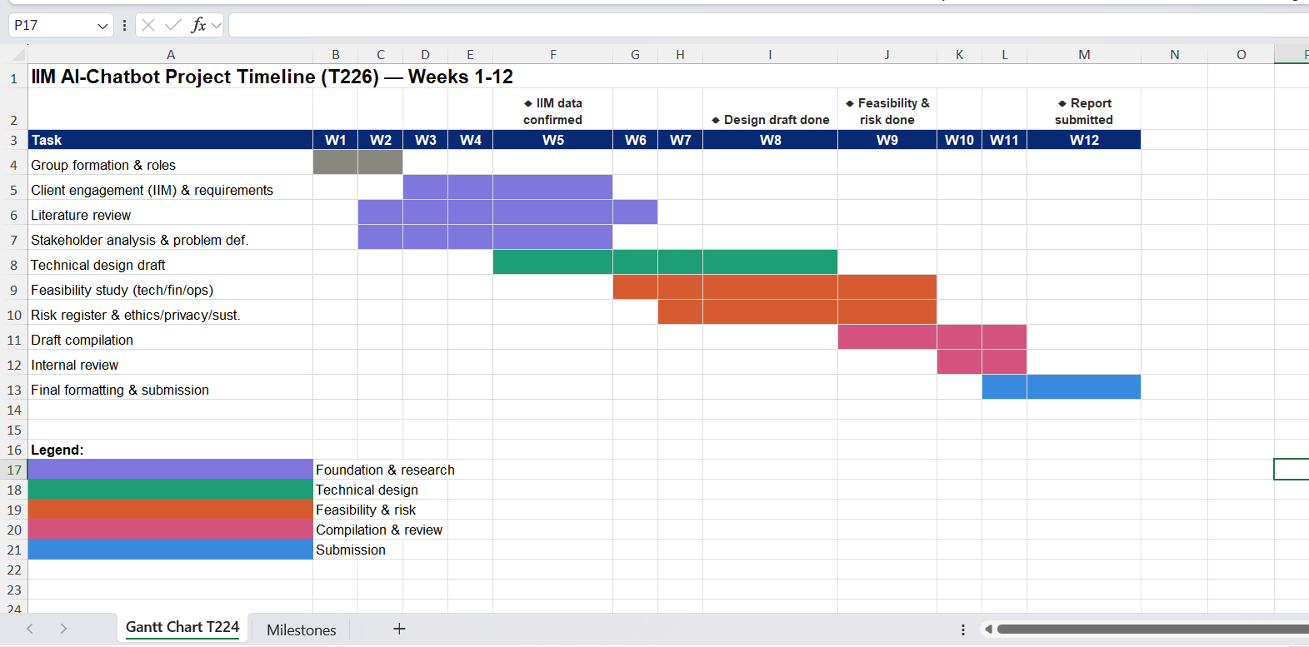
Figure 3: Timeline Chart

Milestone table
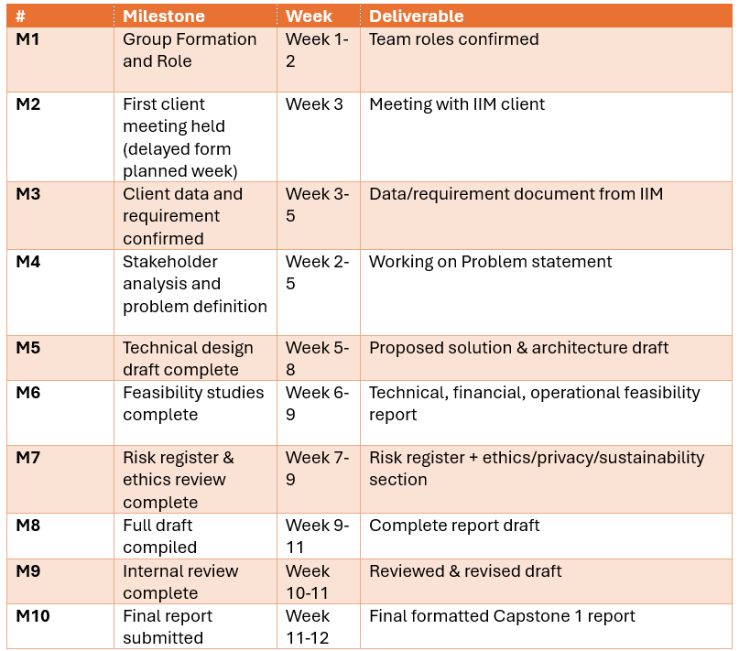
Figure 4: Milestone Table

Roles and Responsibilities
In our project we are divide as 4 members Marjana, Binay, Tanmoy and Rejina where each team members have their own roles and responsibilities.
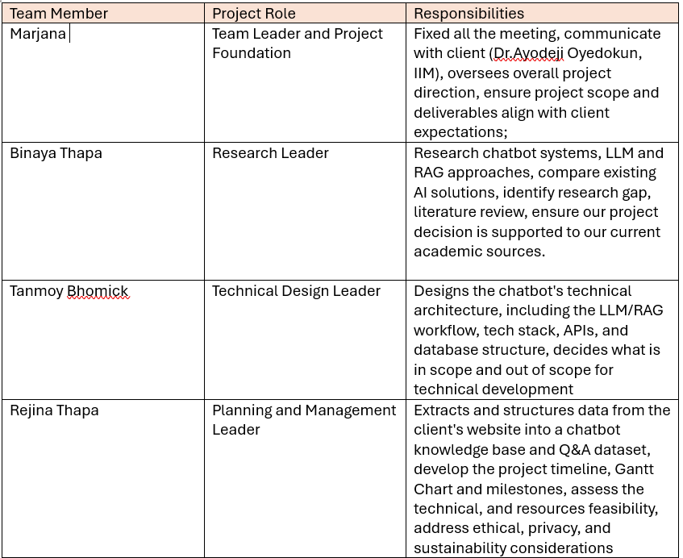
Figure 5: Divided Roles and Responsibilites List

Technical and Resources Feasibility
Our project is fully technical feasibility where we must build a chatbot by using a RAG (Retrieval Augmented Generation) approach. We have to develop the Chatbot for IIM where the chatbot knowledge base is created form the data we extract from the IIM Afrcia website where we have to extract such as membership, certification, and training data. where I already collected and structure this data into a Q&A dataset. However, there are many free and low-cost tolls available such as LLM, APSs and databases in Internet which support this kind of chatbot, luckily our team members does not need advance or expensive technology to build this chatbot.
To complete this project, we divided based on our strength research, technical design, data handling and planning. For now, we have access to free or student-tier tools and platform, so that there is no major financial or resources are required. Overall, this is a capstone 1 project and not a commercial product yet, so that we do not need a budget or any paying tools to complete it.

Risk Identification and Mitigation strategies
In every development phase project need to face some risk and challenges. in chatbot development we might have to face some issues for that we need to identify them early so can we manage them properly.
Our major risk for now is that the client (IIM) takes a long time to respond. They still did not provide any data which we asked from them. To manage this, we created a group in slack as well as in WhatsApp so that we can communicate with the client more easily and get quick response whenever they are available.
Another risk is that our team may not have enough experience working with RAG and chatbot technology which could be problem in Capstone 2. But, to reduce this risk Binay research on chatbot system and LLM is done early, not only the Binay we all do research on it.
Lastly, another risk could be our university workload, as we all study multiple subjects at once, and every member also work, so that we might not always have enough time to focus only this. To manage this, we divided our task clearly and fixed our meeting Schuldes to discuss our weekly progress according to availability.

Ethical, legal, safety and sustainability consideration
Our chatbot will used the data form IIM’s Website. To use their data, we need to make sure that we only use information which are publicly available and does not include any information which are private or sensitive user data. and we need to be transparent with user that they are chatting with AI not any real person.
Form the legal prospective, we need to follow rules and regulation, we need to follow copyright rules when using the client content also make sure that what we used for tools that are used within their term of service. Privacy protection should be consideration in the beginning, if the chatbot is expand in the future to handle personal information form members.
For safety, chatbot need to give accurate data and avoid creating wrong or misleading answer, where user are fully relying on it for information about certification, membership and soon. To developing chatbot we make sure that the chatbot wii be simple and accessible for all users.
For sustainability, chatbot is designed to be maintained easily in the future. The knowledge base can be updated by the client whenever there is any changes in information. Therefore, chatbot can continue to be used in the future without requiring any major development.

Conclusion

References
Asai, A., Wu, Z., Wang, Y., Sil, A. and Hajishirzi, H. (2024) 'Self-RAG: Learning to retrieve, generate, and critique through self-reflection', Proceedings of the Twelfth International Conference on Learning Representations. Available at: https://openreview.net/forum?id=hSyW5go0v8 (Accessed: 30 July 2026).
Botpress (2026) Knowledge bases. Available at: https://botpress.com/docs/studio/concepts/knowledge-base/introduction/ (Accessed: 30 July 2026).
Gao, Y., Xiong, Y., Gao, X., Jia, K., Pan, J., Bi, Y., Dai, Y., Sun, J. and Wang, H. (2023) 'Retrieval-augmented generation for large language models: A survey', arXiv preprint, arXiv:2312.10997. Available at: https://arxiv.org/abs/2312.10997 (Accessed: 30 July 2026).
Hong, M., Zhang, C.J., Jiang, D. and He, Y. (2025) 'Augmenting compliance-guaranteed customer service chatbots: context-aware knowledge expansion with large language models', Proceedings of the 2025 Conference on Empirical Methods in Natural Language Processing: Industry Track, pp. 753–765.
Huang, L., Yu, W., Ma, W., Zhong, W., Feng, Z., Wang, H., Chen, Q., Peng, W., Feng, X., Qin, B. and Liu, T. (2025) 'A survey on hallucination in large language models: Principles, taxonomy, challenges, and open questions', ACM Transactions on Information Systems, 43(2), Article 42. doi: 10.1145/3703155.
Ji, Z., Lee, N., Frieske, R., Yu, T., Su, D., Xu, Y., Ishii, E., Bang, Y., Madotto, A. and Fung, P. (2023) 'Survey of hallucination in natural language generation', ACM Computing Surveys, 55(12), Article 248, pp. 1–38. doi: 10.1145/3571730.
Labadze, L., Grigolia, M. and Machaidze, L. (2023) 'Role of AI chatbots in education: Systematic literature review', International Journal of Educational Technology in Higher Education, 20, Article 56. doi: 10.1186/s41239-023-00426-1.
Lewis, P., Perez, E., Piktus, A., Petroni, F., Karpukhin, V., Goyal, N., Küttler, H., Lewis, M., Yih, W., Rocktäschel, T., Riedel, S. and Kiela, D. (2020) 'Retrieval-augmented generation for knowledge-intensive NLP tasks', Advances in Neural Information Processing Systems, 33, pp. 9459–9474.
Mialon, G., Dessì, R., Lomeli, M., Nalmpantis, C., Pasunuru, R., Raileanu, R., Rozière, B., Schick, T., Dwivedi-Yu, J., Celikyilmaz, A., Grave, E., LeCun, Y. and Scialom, T. (2023) 'Augmented language models: A survey', Transactions on Machine Learning Research. Available at: https://openreview.net/forum?id=jh7wH2AzKK (Accessed: 30 July 2026).
Muthusamy, V., Rizk, Y., Kate, K., Venkateswaran, P., Isahagian, V., Gulati, A. and Dube, P. (2023) 'Towards large language model-based personal agents in the enterprise: Current trends and open problems', Findings of the Association for Computational Linguistics: EMNLP 2023, pp. 6909–6921. doi: 10.18653/v1/2023.findings-emnlp.461.
Okonkwo, C.W. and Ade-Ibijola, A. (2021) 'Chatbots applications in education: A systematic review', Computers and Education: Artificial Intelligence, 2, Article 100033. doi: 10.1016/j.caeai.2021.100033.
Rakin, S., Shibly, M.A.R., Hossain, Z.M., Akbar, M.M. and Khan, Z. (2025) 'Leveraging the domain adaptation of retrieval augmented generation models for question answering and for hallucination reduction', International Conference on Information Technology-New Generations, pp. 482–493. Cham: Springer Nature Switzerland.
Rasa Technologies (2026) Rasa documentation. Available at: https://rasa.com/docs/ (Accessed: 30 July 2026).
Wangsa, K., Karim, S., Gide, E. and Elkhodr, M. (2024) 'A systematic review and comprehensive analysis of pioneering AI chatbot models from education to healthcare: ChatGPT, Bard, Llama, Ernie and Grok', Future Internet, 16(7), Article 219. doi: 10.3390/fi16070219.
Zhang, W. and Zhang, J. (2025) 'Hallucination mitigation for retrieval-augmented large language models: a review', Mathematics, 13(5), p. 856.
Zhang, Y., Lau, R.Y.K., Xu, J.D., Rao, Y. and Li, Y. (2024) 'Business chatbots with deep learning technologies: State-of-the-art, taxonomies, and future research directions', Artificial Intelligence Review, 57, Article 113. doi: 10.1007/s10462-024-10744-z.
Zhao, P., Zhang, H., Yu, Q., Wang, Z., Geng, Y., Fu, F., Yang, L., Zhang, W., Jiang, J. and Cui, B. (2024) 'Retrieval-augmented generation for AI-generated content: A survey', arXiv preprint, arXiv:2402.19473. Available at: https://arxiv.org/abs/2402.19473 (Accessed: 30 July 2026).
Zhao, W.X., Zhou, K., Li, J., Tang, T., Wang, X., Hou, Y., Min, Y., Zhang, B., Zhang, J., Dong, Z., Du, Y., Yang, C., Chen, Y., Chen, Z., Jiang, J., Ren, R., Li, Y., Tang, X., Liu, Z., Liu, P., Nie, J.Y. and Wen, J.R. (2023) 'A survey of large language models', arXiv preprint, arXiv:2303.18223. Available at: https://arxiv.org/abs/2303.18223 (Accessed: 30 July 2026).
Gao, Y., Xiong, Y., Gao, X., Jia, K., Pan, J., Bi, Y., Dai, Y., Sun, J., Wang, M. and Wang, H. (2023) ‘Retrieval-augmented generation for large language models: a survey’, arXiv preprint arXiv:2312.10997. DOI: 10.48550/arXiv.2312.10997.
Grattafiori, A. et al. (2024) ‘The Llama 3 herd of models’, arXiv preprint arXiv:2407.21783. DOI: 10.48550/arXiv.2407.21783.
Institute of Information Management (IIM) Africa (2026) Internal organisational documentation provided for the capstone project (unpublished).
Lewis, P., Perez, E., Piktus, A., Petroni, F., Karpukhin, V., Goyal, N., Küttler, H., Lewis, M., Yih, W., Rocktäschel, T., Riedel, S. and Kiela, D. (2020) ‘Retrieval-augmented generation for knowledge-intensive NLP tasks’, Advances in Neural Information Processing Systems, 33, pp. 9459–9474.
Ollama (no date) Ollama documentation. Available at: https://ollama.com (Accessed: 29 July 2026).
OpenAI (no date) OpenAI API reference. Available at: https://platform.openai.com/docs (Accessed: 29 July 2026).
Touvron, H., Lavril, T., Izacard, G., Martinet, X., Lachaux, M.-A., Lacroix, T., Rozière, B., Goyal, N., Hambro, E., Azhar, F., Rodriguez, A., Joulin, A., Grave, E. and Lample, G. (2023) ‘LLaMA: open and efficient foundation language models’, arXiv preprint arXiv:2302.13971. DOI: 10.48550/arXiv.2302.13971.

